Model-View-Presenter (MVP)
# Source: AI Source: Provided by: [Data Path: Persons Table -> ID Column: 1, Name_En Column: Motasem Essam] -> From: [ChatGPT] on [1/23/2026]
Model-View-Presenter (MVP) is an architectural pattern that separates an application into Model, View, and Presenter, emphasizing clear responsibility and testability.
👉 Think of it like:
- Model = Data & business logic
- View = UI
- Presenter = Handles all UI logic and mediates between Model and View

🔑 Key Idea
# Source: AI Source: Provided by: [Data Path: Persons Table -> ID Column: 1, Name_En Column: Motasem Essam] -> From: [ChatGPT] on [1/23/2026]
The View is passive; it only displays data and forwards user events to the Presenter, which handles the logic.

🧱 Structure
# Source: AI Source: Provided by: [Data Path: Persons Table -> ID Column: 1, Name_En Column: Motasem Essam] -> From: [ChatGPT] on [1/23/2026]
View → Presenter → Model
- View → Displays data and forwards user actions
- Presenter → Contains UI logic, interacts with Model, updates View
- Model → Business logic and data

🧩 Example

Model
# Source: AI Source: Provided by: [Data Path: Persons Table -> ID Column: 1, Name_En Column: Motasem Essam] -> From: [ChatGPT] on [1/23/2026]
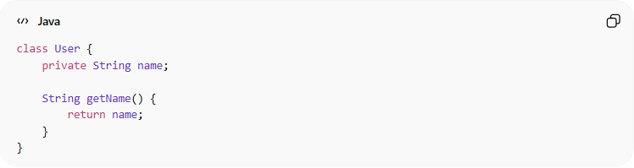
class User {
private String name;

String getName() {
return name;
}
}

Presenter
# Source: AI Source: Provided by: [Data Path: Persons Table -> ID Column: 1, Name_En Column: Motasem Essam] -> From: [ChatGPT] on [1/23/2026]
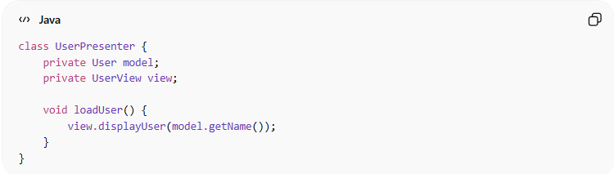
class UserPresenter {
private User model;
private UserView view;

void loadUser() {
view.displayUser(model.getName());
}
}

View
# Source: AI Source: Provided by: [Data Path: Persons Table -> ID Column: 1, Name_En Column: Motasem Essam] -> From: [ChatGPT] on [1/23/2026]
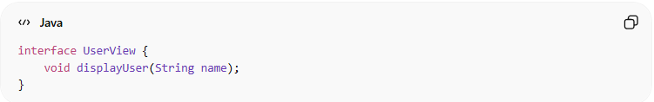
interface UserView {
void displayUser(String name);
}
- Concrete view implements UserView and delegates user actions to UserPresenter.

❌ Bad Example (Without MVP)
# Source: AI Source: Provided by: [Data Path: Persons Table -> ID Column: 1, Name_En Column: Motasem Essam] -> From: [ChatGPT] on [1/23/2026]
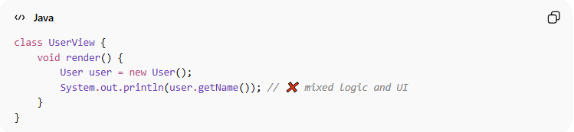
class UserView {
void render() {
User user = new User();
System.out.println(user.getName()); // ❌ mixed logic and UI
}
}
👉 Problems:
- UI and logic tightly coupled
- Hard to test

✅ Benefits
# Source: AI Source: Provided by: [Data Path: Persons Table -> ID Column: 1, Name_En Column: Motasem Essam] -> From: [ChatGPT] on [1/23/2026]
- Clear separation of concerns
- View is passive → easier to test Presenter
- Flexible and maintainable
- UI changes don’t break business logic

⚠️ Drawbacks
# Source: AI Source: Provided by: [Data Path: Persons Table -> ID Column: 1, Name_En Column: Motasem Essam] -> From: [ChatGPT] on [1/23/2026]
- More boilerplate than MVC
- Slightly more complex to set up
- Not ideal for very simple apps

⚡ When to Use
# Source: AI Source: Provided by: [Data Path: Persons Table -> ID Column: 1, Name_En Column: Motasem Essam] -> From: [ChatGPT] on [1/23/2026]
- Desktop applications (WinForms, Swing)
- Android apps (classic MVP)
- Projects where testable UI logic is important

🔄 MVC vs MVVM vs MVP (Quick Comparison)
# Source: AI Source: Provided by: [Data Path: Persons Table -> ID Column: 1, Name_En Column: Motasem Essam] -> From: [ChatGPT] on [1/23/2026]
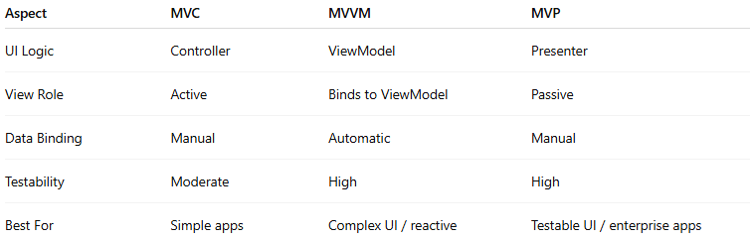
Aspect | MVC | MVVM | MVP
UI Logic | Controller | ViewModel | Presenter
View Role | Active | Binds to ViewModel | Passive
Data Binding | Manual | Automatic | Manual
Testability | Moderate | High | High
Best For | Simple apps | Complex UI / reactive | Testable UI / enterprise apps

💡 Summary
# Source: AI Source: Provided by: [Data Path: Persons Table -> ID Column: 1, Name_En Column: Motasem Essam] -> From: [ChatGPT] on [1/23/2026]
MVP makes the View passive and moves all UI logic to the Presenter, improving testability and maintainability.

